|  |  |
| --- | --- |
| **Programming II**  Diploma in IT / DS / CSF  Year 1 (2021/22) Semester 2 | Week 8 |
| 2 hours |
| **Practical 8 Class Associations (Part 1)** | |

ADVANCED

1. Create a new Console Project **PosApp** in Visual Studio 2019 and do the following:
2. Implement the classes in the following diagram that shows the associations between the **ShoppingCart**, **CartItem,** and **Product** classes.

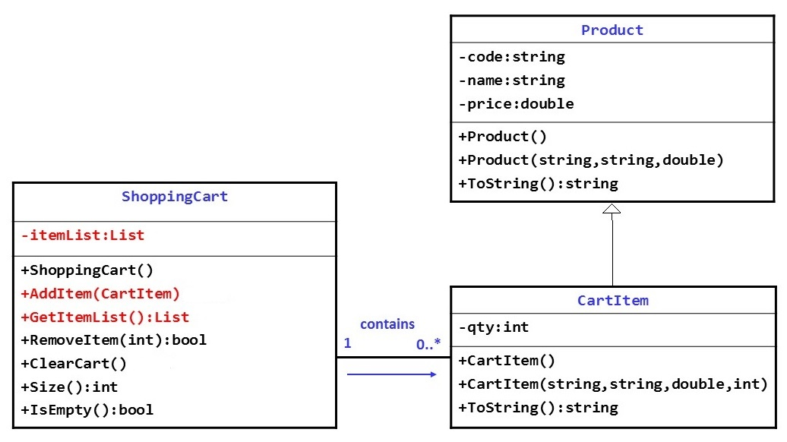

1. Write code in the *Main()* method to do the following:
2. Declare a List, **productList**, to store the objects of **Product** class.
3. Create product objects with the information (i.e. product code, name, and price) given below and stored them into the **productList**.

|  |  |  |  |  |
| --- | --- | --- | --- | --- |
| 1001  Apple iPhone  1088.00 | 1005  HTC  Sensation  888.00 | 1013  LG  Optimus 2X  788.00 | 1022  Motorola  Atrix  958.00 | 1027  Samsung  Galaxy  988.00 |

1. Declare and create a **ShoppingCart** object to store **CartItem** objects.
2. Display a simple menu as shown below:

|  |
| --- |
| ---------------- M E N U ----------------- [1] List all products and prices  [2] Add item to cart  [3] View cart items [4] Remove item from cart [5] Clear cart items [0] Exit ------------------------------------------ Enter your option : |

1. Complete the program to process the option selected by the user as follows:

Option 1: List all the products and prices

*- display all the products and their prices*

Option 2: Add item to cart

*- display all the products and their prices*

*- prompt user to select the item number*

*- prompt user to enter the quantity*

*- create a CartItem object with the given information*

*- add the CartItem object to the shoppingcart*

Option 3: View cart items

*- display all the items in the cart (including sub-totals and grand total)*

Option 4: Remove item from cart

*- display all the items in the cart*

*- prompt user to select the item number to remove*

*- remove the selected cart item from the cart*

Option 5: Clear cart items

*- remove all the cart items from the cart*

Option 0: Exit the program

1. Test the program

*You should test each option by producing a test plan. If there are errors, correct them and try again.*

**Plagiarism Warning:**

**If a student is found to have submitted work not done by him/her, he/she will not be awarded any marks for this practical. Disciplinary action may also be taken.**

**Similar action will be taken for student who allows other student(s) to copy his/her work.**